|  |  |
| --- | --- |
| Image result for elevations credit union | **User Manual**  **Elevation Credit Union**  **Final Group submission**  **IST 647**  **Prof. Conrad Shayo**  **Group Members**  **Mohammed Saad 006712128**  **Shubhankar Jathar 006704614**  **Swapnil Nikam 006706772**  **Digvijay Singh Deora 005791834** |

**Index**

**Introduction……………………………………………………………………………………………2**

**User Requirement Specification Matrix…………………………………………………..2**

**Conceptual diagram………………………………………………………………………………..4**

**Logical diagram……………………………………………………………………………………….5**

**Creating Tables in SQL…………………………………………………………………………….5**

**Inserting Values in Tables………………………………………………………………………..6**

**Steps to link SQL data with MS Access through SQL server………………………7**

**Steps to Execute the Front End (MS Access)…………………………………………….9**

**Security and Authentication…………………………………………………………………………..9**

**Forms..……………………………………………………………………………………………………..10**

**Menus…………….………………………………………………………………………………………..11**

**Reports….………………………………………………………………………………………………….12**

**Introduction**

Elevations Credit Union is member owned, not for profit credit union serving Boulder, Broomfield, Larimer, and Adams Counties – their field of membership. Malcolm Baldrige report on this credit union provides us with a deeper insight on how the company as an organization operates in the real world.

This manual provides the in-detail view on the database management system created for the bank. Which includes 12 different data tables like Customer, Employee, Revenue, Branch, Member, etc. The steps for creating these tables using the SQL Server Management Studio as a tool are shown below.

While preparing the tables, we went through the Logical and Conceptual diagrams of the database, in order to create queries having the proper foreign keys. The conceptual diagram for the database system is as given below.

Ones these tables were created and dummy data input in these tables, we performed the connection with Microsoft Access and linked all the tables to Access from the SQL server installed. We then created forms in MS Access for the tables given, and sub forms which linked 2 or 3 different tables. We execute them through the Switchboard prepared.

Then we ran queries that would replicate the results according to the 7th section of Malcolm Baldrige paper i.e., ‘Reports’. With the data obtained from those queries we plot the graphs in MS Excel spreadsheets to show the relationship. We enabled the User ID and password for MS Access data. We tried to add Security in the SQL server.

Below are the guidelines to the database.

**User Requirement specification matrix**

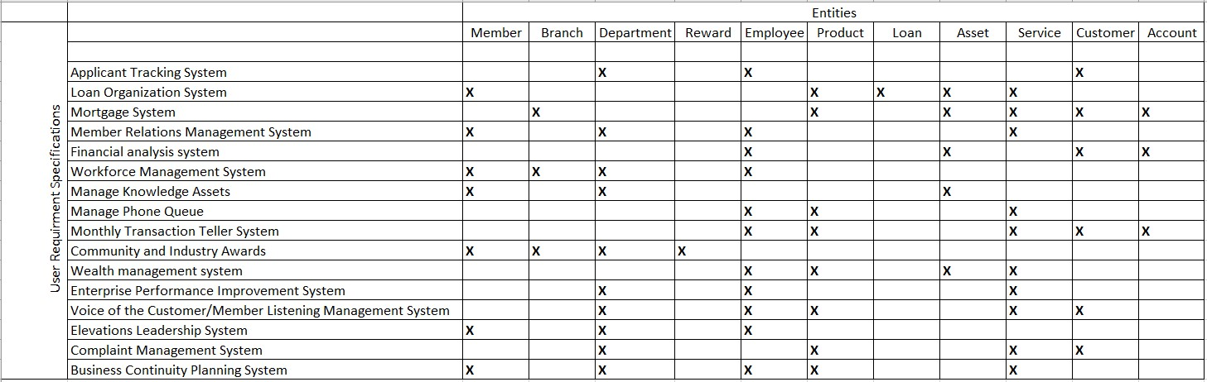

**Business process or use case matrix**

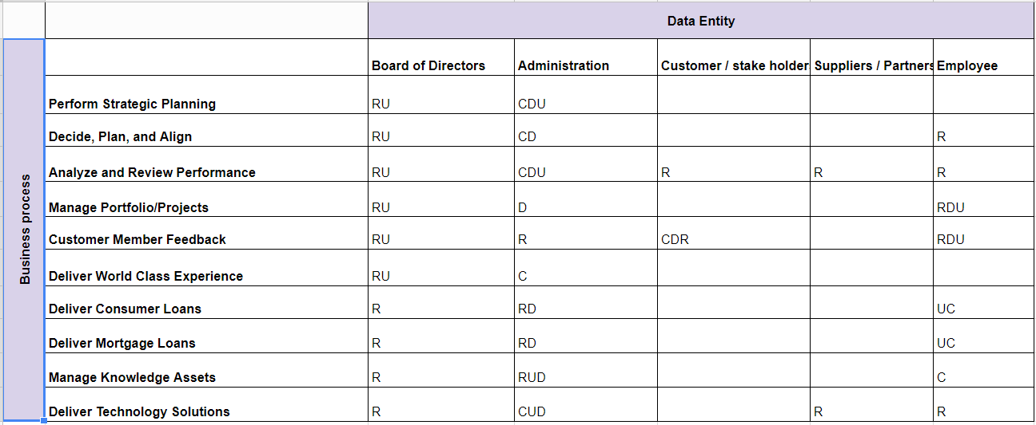

**Processes and entity matrix**

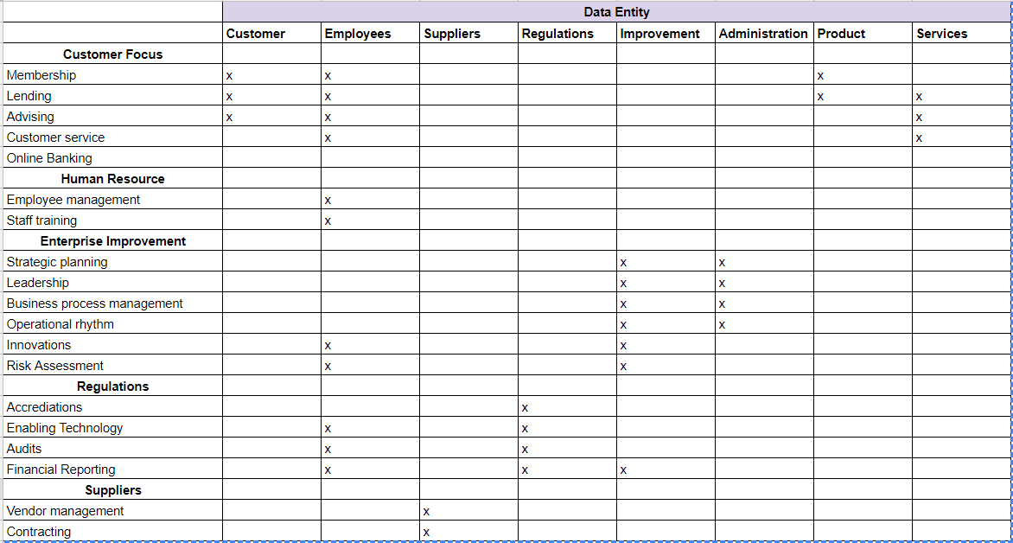



**Conceptual Diagram**

**Logical View Diagram**

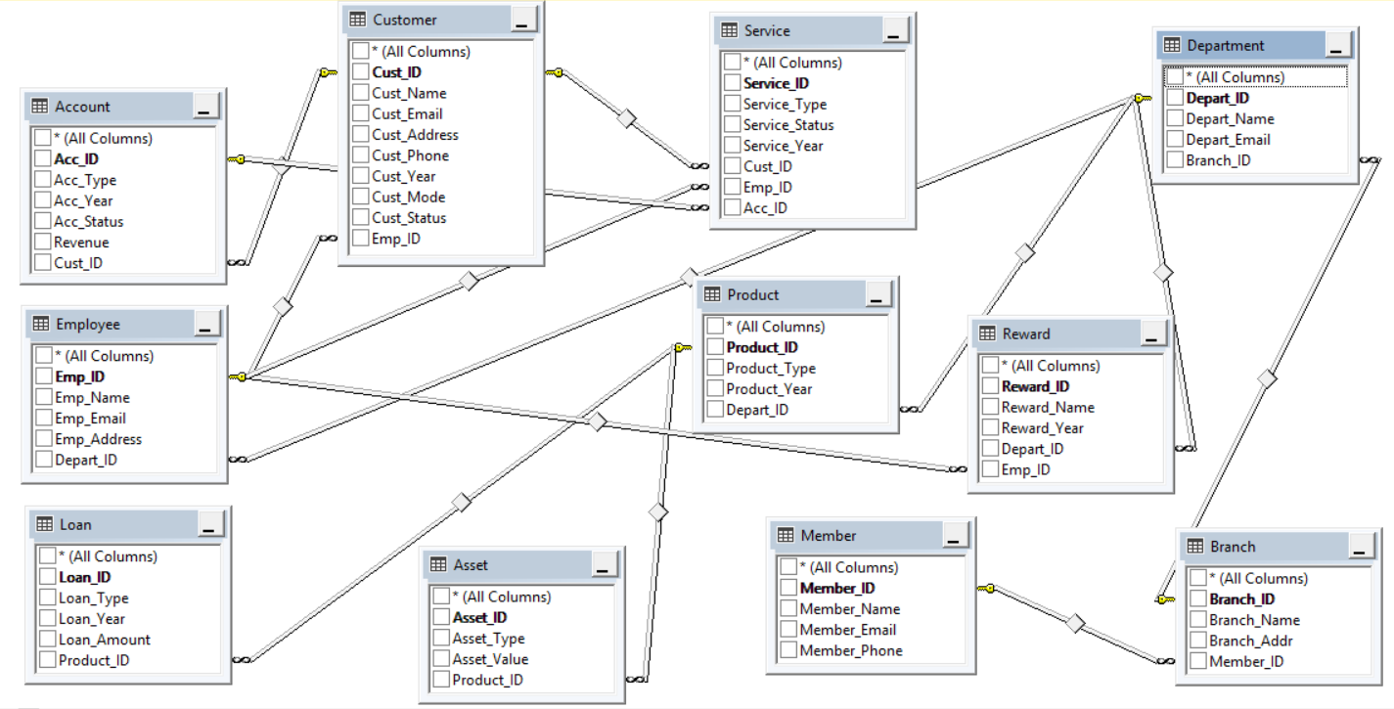

**Create Table in SQL**

Queries have to be written and executed in the MS SQL server management studio.

Step 1: Right click on Database (example: we took database name as credit_union), Select New Query.

Step 2: Enter the query on the right side blank space, and click on green execute icon in toolbar. Tables will be created in the Tables inside database.

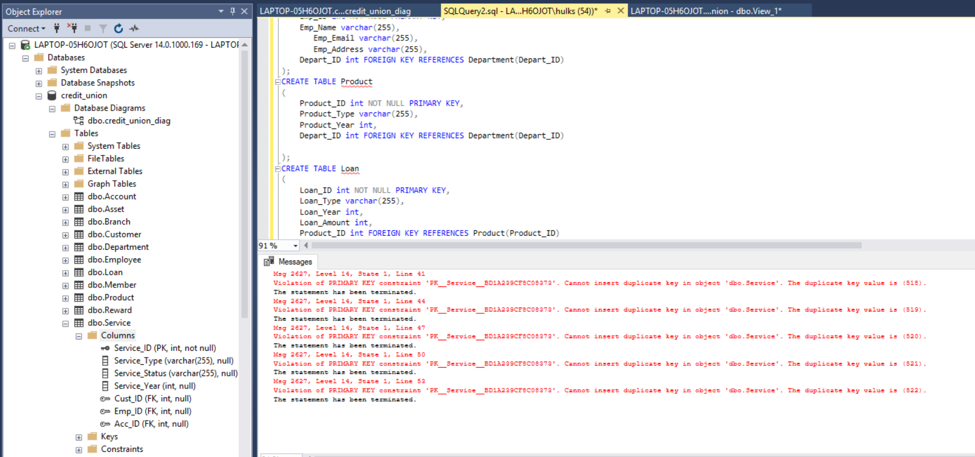

**Inserting Values in tables**

To insert dummy values in the tables we need to input the insert queries.

Step 1: Follow the same steps as Create table queries. The only difference here is that the values in the queries will be stored in the tables created.

Step 2: We need to make sure to maintain referential integrity here. Because if we try to enter data into a table that has foreign key, it will show an error. Thus we need to insert values in a sequence. Ones the values are input in the table we now need to link the tables with front end i.e., MS ACCESS.

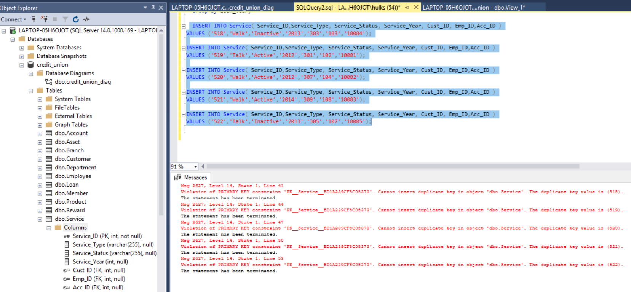

**Database diagrams generated by SQL** : SQL also generates Database diagrams ones we have defined the referential integrity. It automatically connects with the foreign keys.

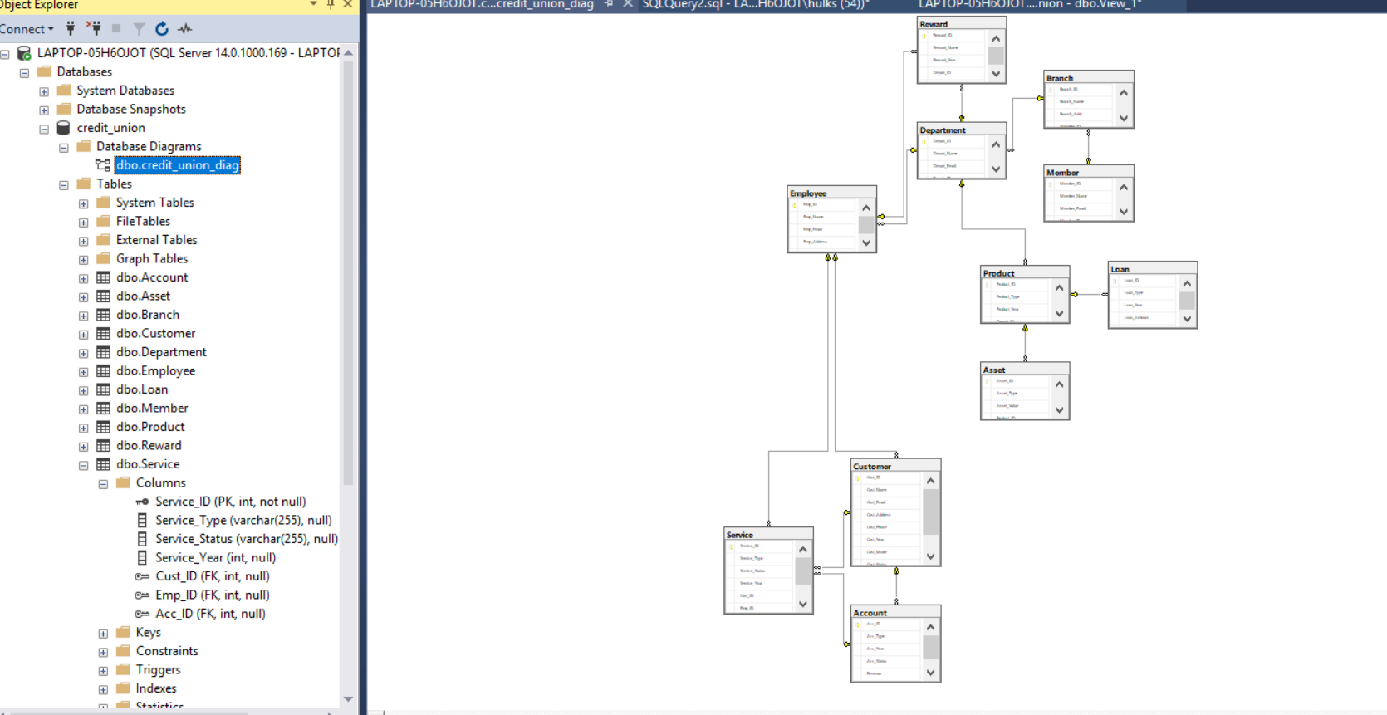

**Steps to link SQL to MS Access through SQL sever**

**Step 1**: Click on ‘External Data’ -> New Data source -> From Other Sources -> ODBC Database.

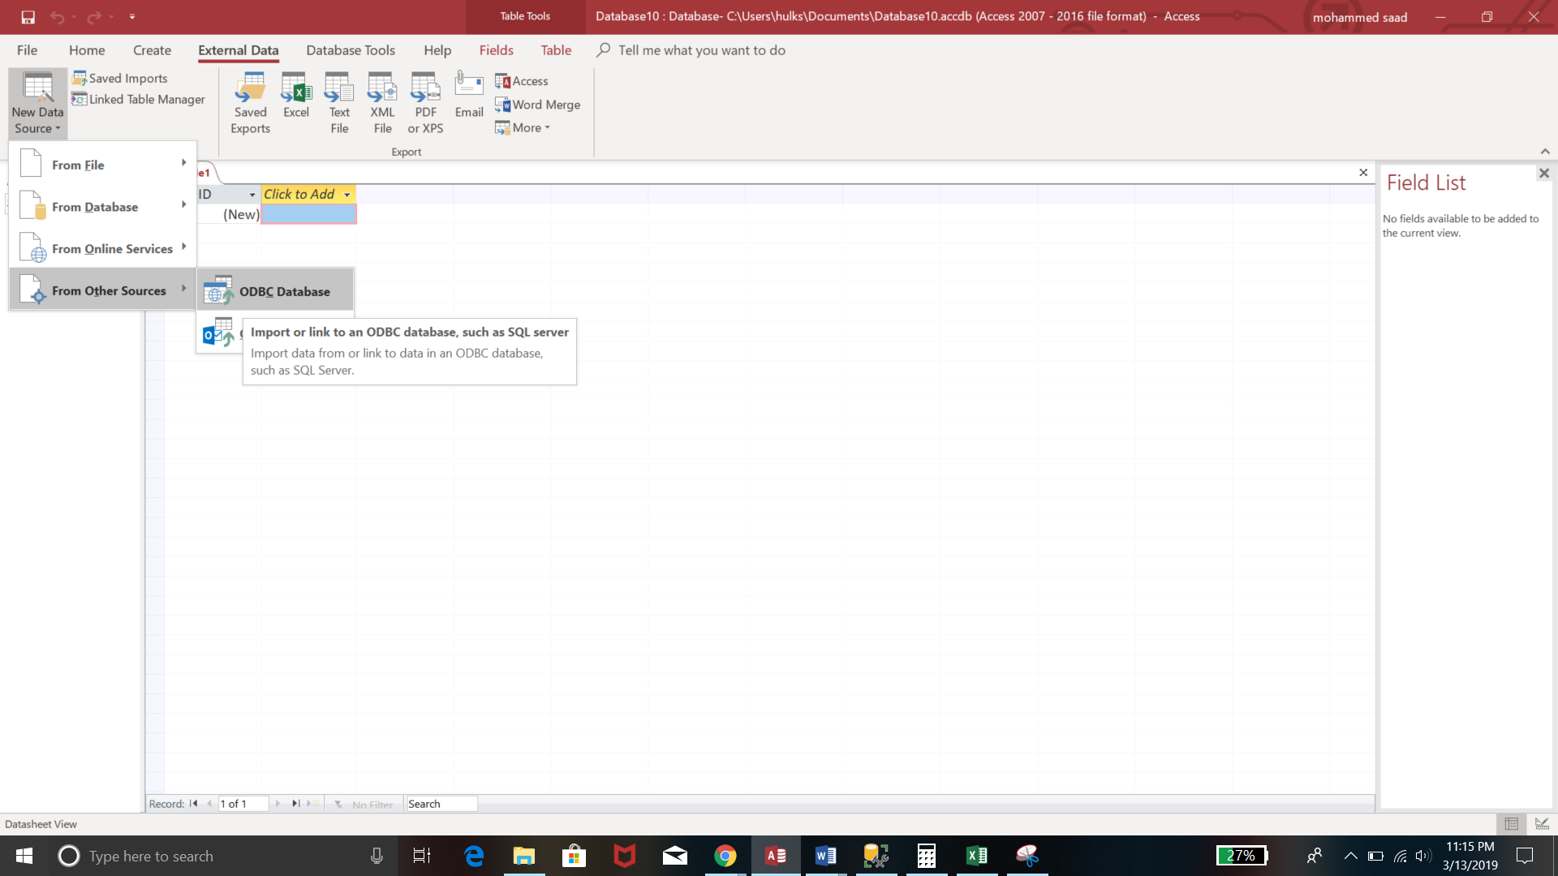

**Step 2:** Ones we click on the ODBC Database option, we get this menu, we select ‘Link the Data source’ option here.

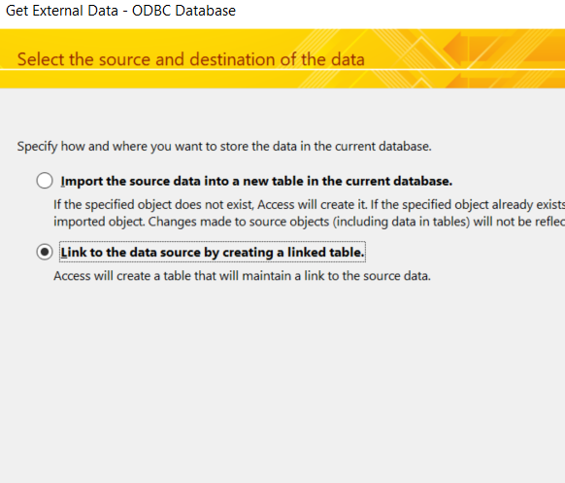

**Step 3:** We have to select the Server, on which we link the data through.

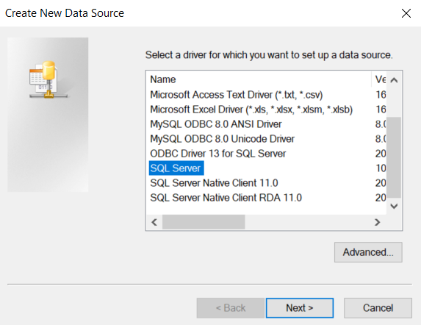

**Step 4:** This step selects the remote server, that is our own computer, automatically.

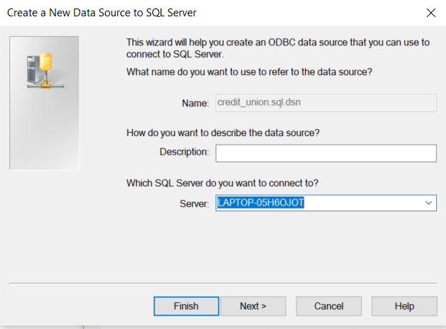

**Step 5:** We have to select the name of database that we input in the SQL. And click Next.

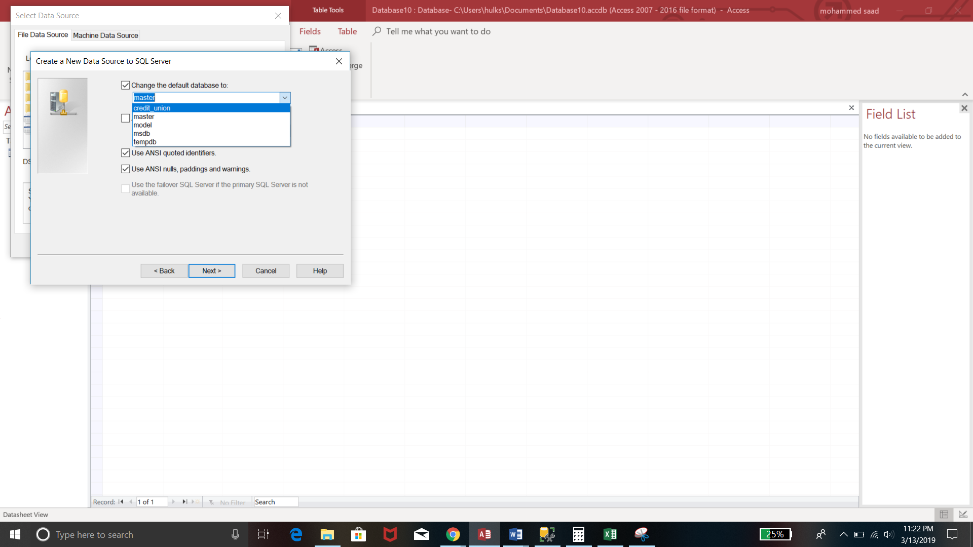

**Step 6:** We select the tables that we need in access to create the front end. Ones we do this all the tables are imported to Access.

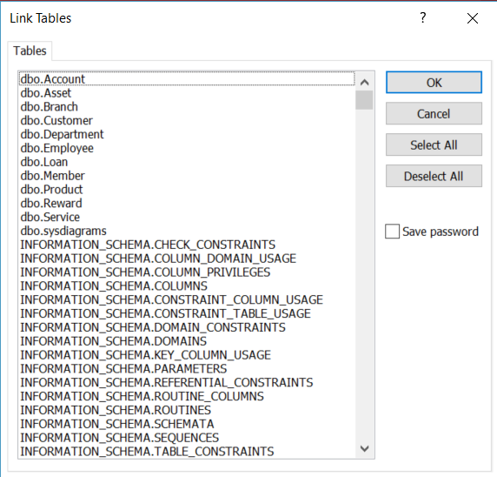

We will now see the working of the this database management system.

**Steps of Executing Front End i.e., MS Access**

**Step 1:**

**Encryption of the Database in Access**:

We have to encrypt the file or the database in order to avoid unauthorized access to database. We can do it in access by following steps.

Step 1: Open the database in Exclusive format in Access, ones we open the tool, we get a popup for entering password.

Step 2: Ones the authenticated user enters password it will allow us to move further with the database in Access.

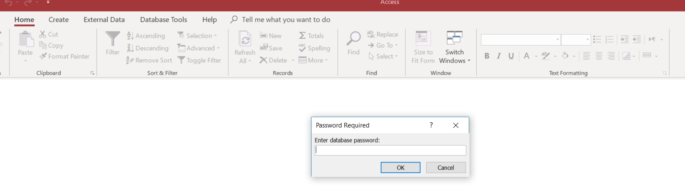

**Step 2:**

**Forms & Views** Ones we enter Access we see a Switchboard.

Step 1: We select the option that we need which takes us to a form where we start with entering the data. Example Account data of the customer should be entered in the account table.

Step 2: Ones we enter the data in the form, we save the entry, and refresh the form.

Step 3: The data is automatically input in the table.

**Switchboard**

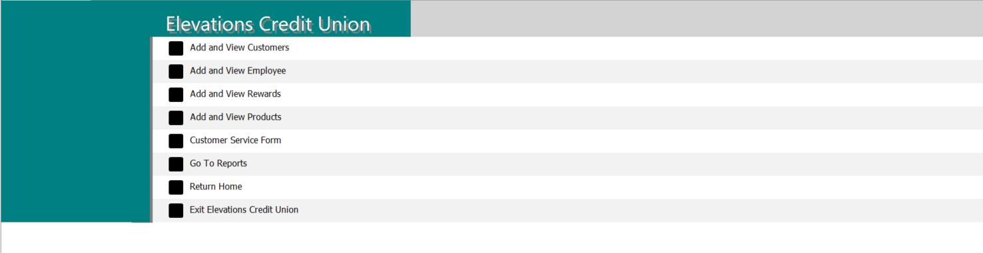

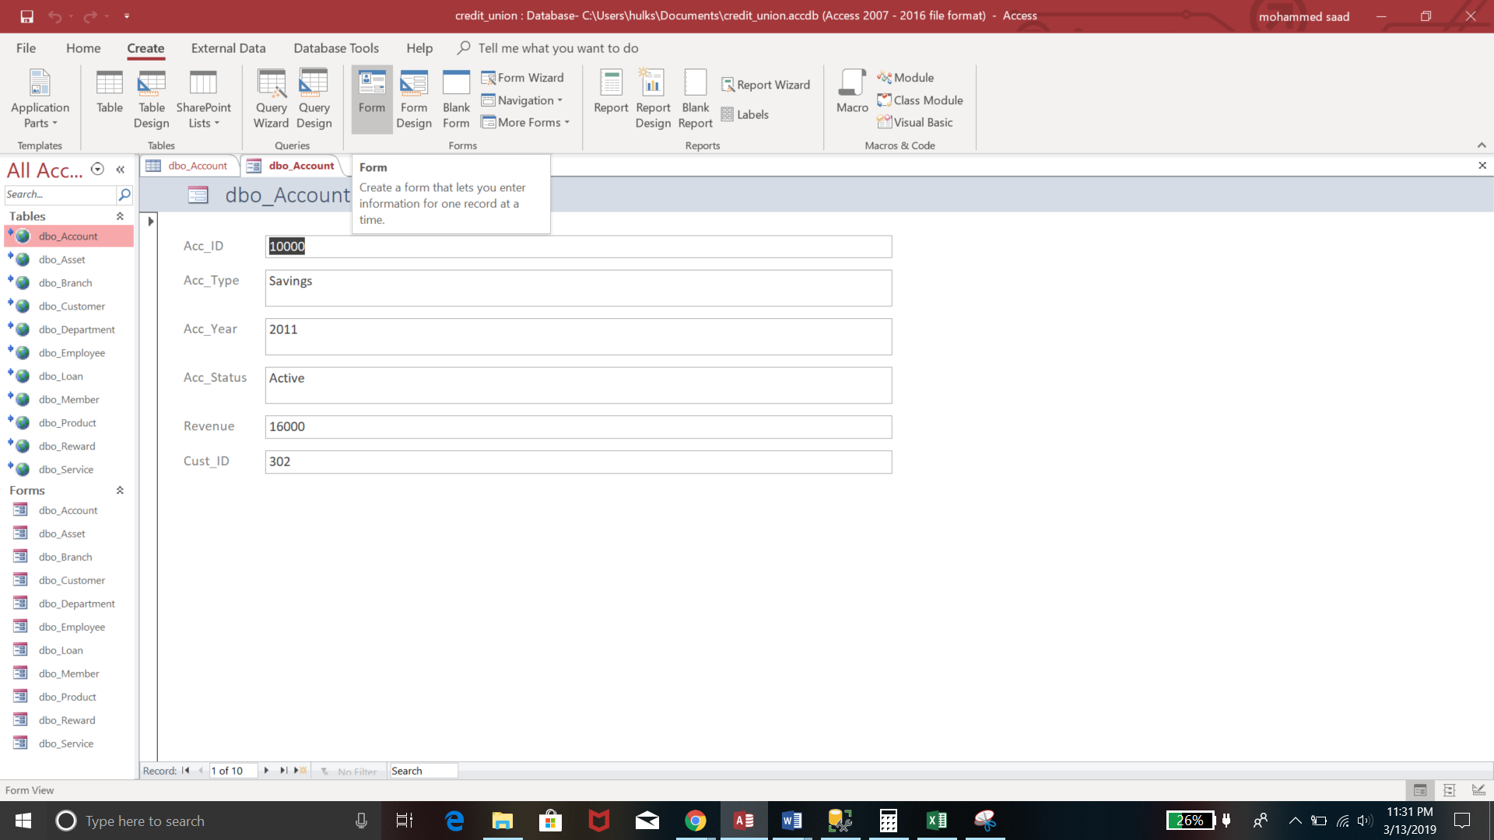

**Step 3:** **Entering data in tables through forms:**

We have the drop-down menus, and the toggle buttons, which will help us navigate to the next form.

With help of all these options, enter the data and save the form menu. Press Add to proceed in every table to enter the data.

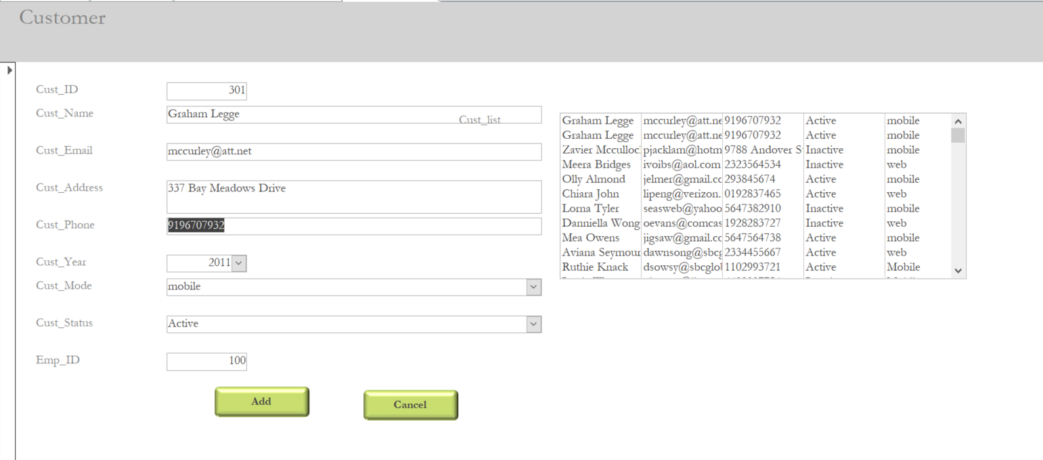

**Step 4:** **Linking two forms to access the data from the tables**

The Database management system here has few forms, which is a combination of 2 or more tables, which will help us get access to those tables easily.

Open the form, example: Customer- Account form. Enter the credentials to get the specific data from the tables.

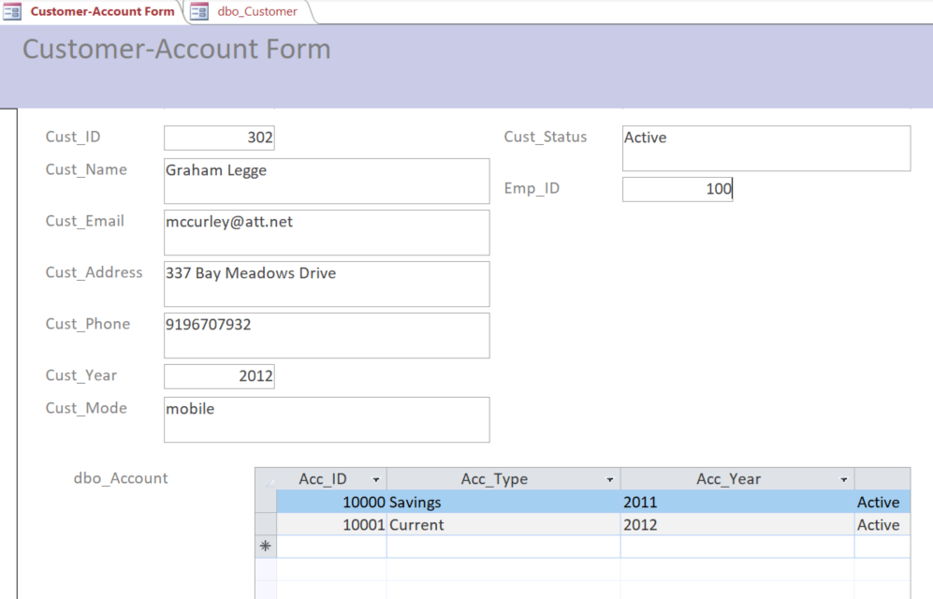

Example of Customer-Service application in a sub form:

This is the next step in the process, which gives us the data we require from both tables.

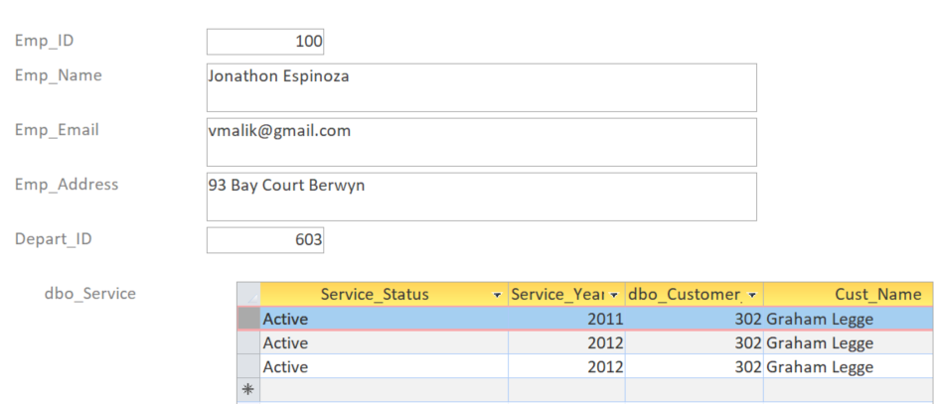

**Step 5:**

**Creating Reports:**

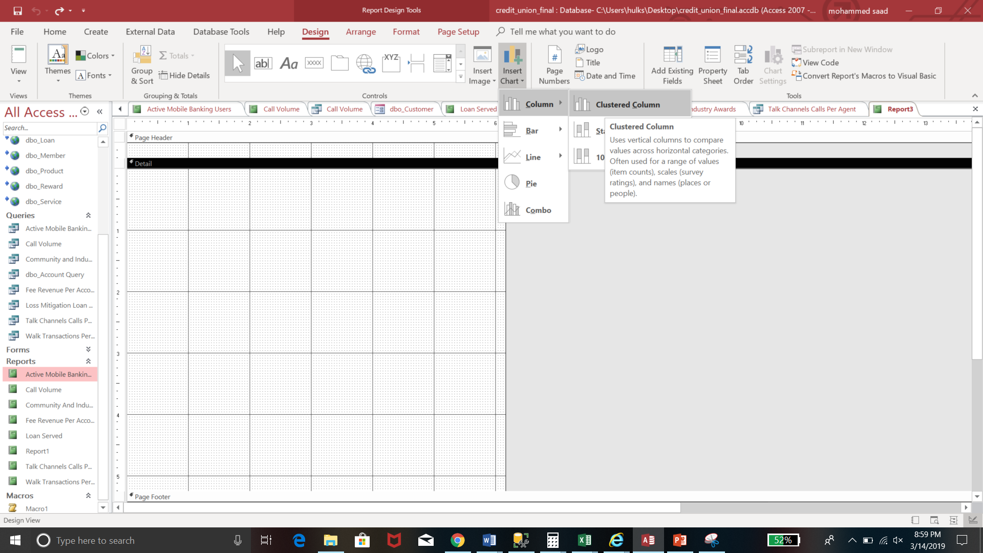

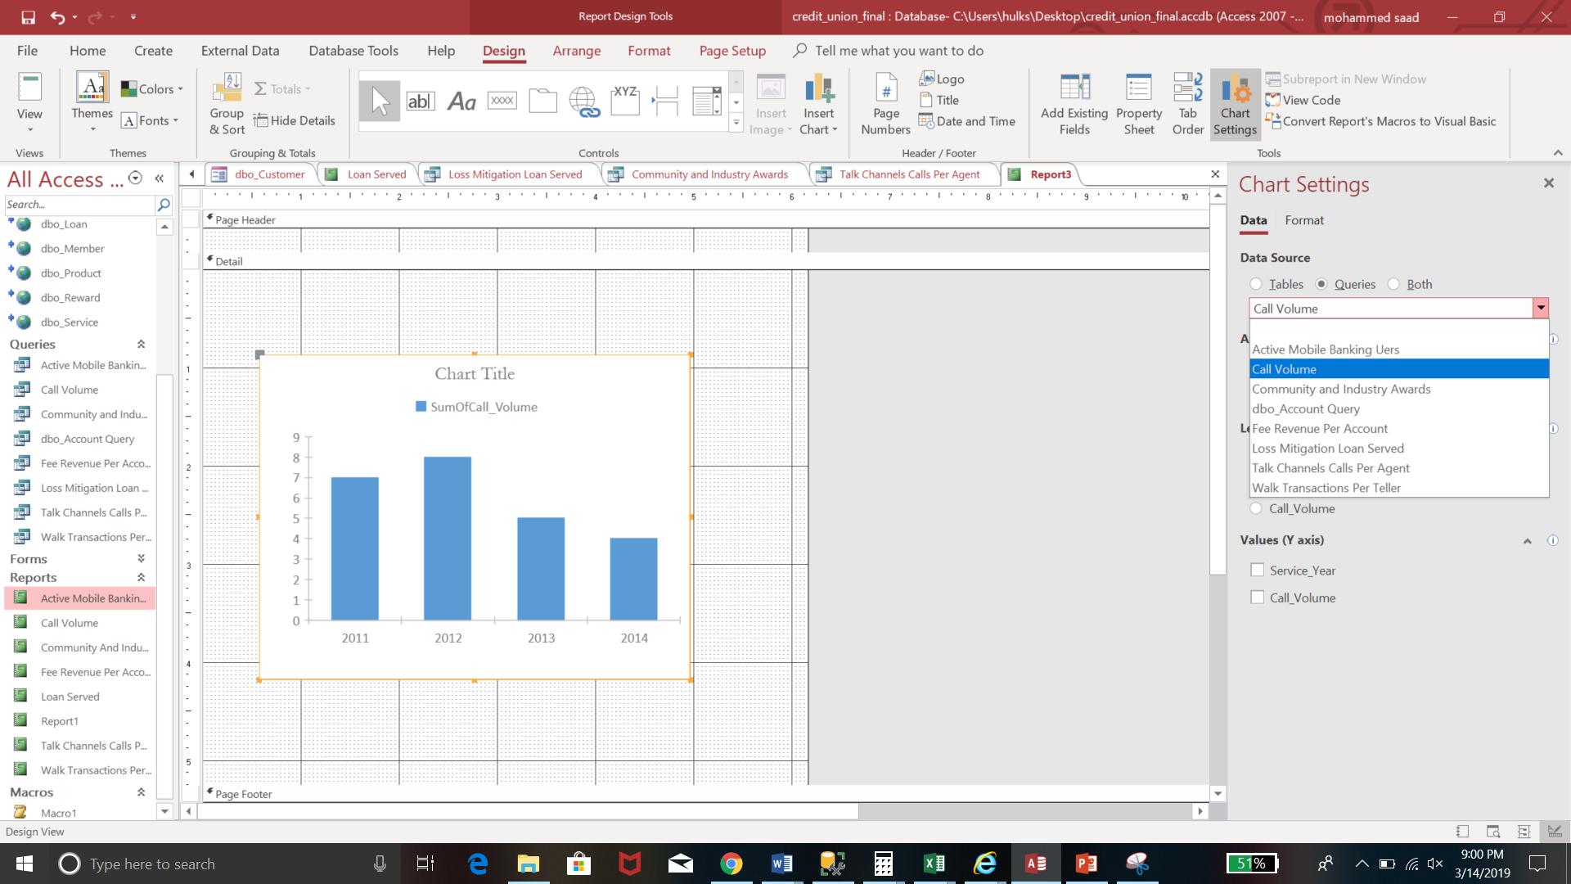

Final Queries

We run the final Queries in MS Access -> Create -> Query design -> SQL view, which gives us the output required as below.

**Report 1: Active Mobile Banking Users**

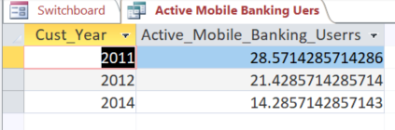

Plotting graphs in spreadsheet from obtained data in SQL

With the obtained output from the queries, we plot the graphs in MS Access. This gives us the reports as below:

This report explains us the active mobile banking users in 4 years starting from 2011-14.

Report 1: This report is a comparison of the report given in the Malcolm Baldrige and the output we have received from our dummy data.

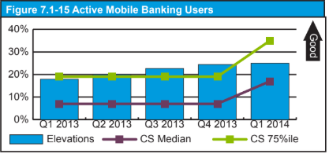

**Report 2**

**Call Volume**

The report here gives the count of number of calls received by employees, who work as customer service executives in 4 years i.e., 2011-14. Below is the comparison between the output from the Malcolm Baldrige report and the output from the data we input as dummy.

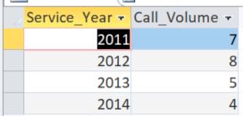

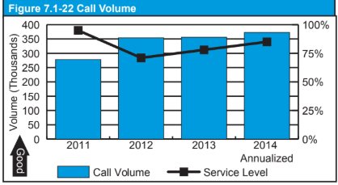

**Report 3:**

**Fee Revenue Per Account**

The report here gives the average Fee Revenue per account, for 4 years in a row i.e., 2011-14. Below are the comparison of the report from the Malcolm Baldrige report and the report we got from our dummy data.

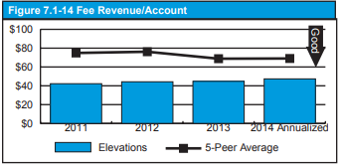 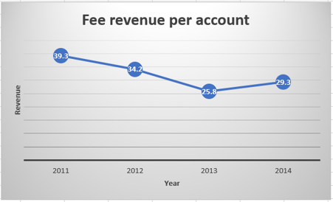

**Report 4:**

**Loans Served**

This report explains the Loans served at the credit union, which consists of Loans saved, in the Malcolm Baldrige report and with the dummy data created in SQL, we got the output of the report as below. Which varies from year to year. We considered to loan in thousands, instead of millions.

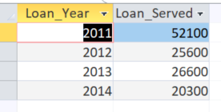

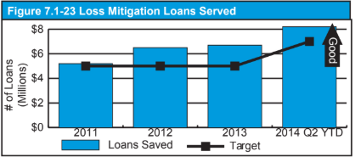

**Report 5:**

**Community and Industry Awards**

The fifth report we demonstrate here is the report of Community and the industry awards received by the Credit Union. We see that by increasing years bank has maintained its credibility and has received Awards in increasing order.

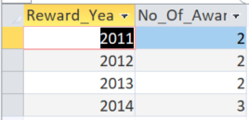

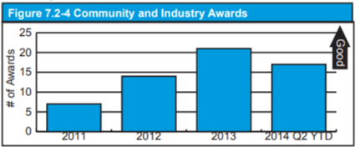

**Report 6:**

**Talk channel Calls per Teller**

From the reports here we can see the number of calls answered per teller i.e., Elevations have received 90 calls per day in average in year as per the Malcolm Baldrige report, but where as the dummy data we input says that bank answers 2 calls per day on average.

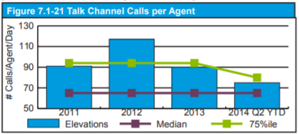

**Report 7:**

**Walk Transactions per teller**

Final report here has the graph from Malcolm Baldrige report, which gives us a count of number of walkin transaction happening in the credit union. According to the report we see that there has been an increase in the walkin transactions happening at the credit union.

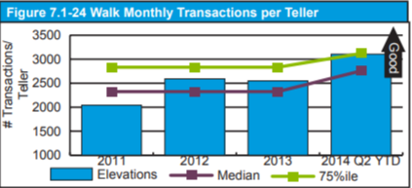

Thus is the completion of the user manual here !! Hope you find it useful.